

Strategic Communication & Negotiations

## Brookings Executive Education University of South Florida

Strategic Communication & Negotiations

#### Sept. 28-29, 2016

University of South Florida College of Arts and Sciences 4202 E. Fowler Ave., CPR 107

Tampa, FL 33620

Course Contact Adib Farhadi, Ph.D. [farhadi@usf.edu](mailto:farhadi@usf.edu)

## Strategic Communication and Negotiations

**September 28-29, 2016 Tampa, FL**

Communications become strategic when they are placed at the center of forging collaborative

relationships and negotiating practical solutions. This program introduces new thinking, based on leading research, on how to maximize the likelihood of influencing others by introducing a three step process. The first step involves developing a deep understanding of existing interactions from the other person’s perspective. The second step develops the habit of communicating in a purposeful and strategic manner in the service of accomplishing goals. The third step develops a deep appreciation for how potential audiences make sense of communication from their cultural perspectives.

In discussing these three steps, participants will develop insights into why they have succeeded or failed in communicating in the past, as well as learn practical techniques for maximizing the likelihood of succeeding in the future. The course will introduce several important, yet underappreciated topics about the dynamics of negotiation across cultural differences that can greatly affect outcomes. The course is designed to prepare participants to become better negotiators in complex cross-cultural business and conflict resolution contexts and develop skills that can manage or prevent conflict. It also presents an introduction to cross-cultural conflict resolution—especially in conflict zones—with an in-depth practitioner’s case. Specific attention is given to religion, tribalism, ethnicity, language, race, and gender, which is necessary to developing a comprehensive approach.

Participants will accumulate new knowledge, insights, and thinking that will help them meet the 21st century challenge of strategic communication and negotiations.

**Two-Day Program Learning Objectives:**

* Understand your communication style
* Define and practice conscious communication
* Learn how to build successful collaborative relationships
* Understand the differences between cross-cultural international negotiations and traditional negotiations
* Understand the dynamics of international negotiations and conflict resolution, and examine how culture can impact the outcomes
* Learn how to choose and apply negotiating tools

**Day One: Wednesday, September 28 Strategic Communication**

**7:30 – 8:00 AM Program Registration, Breakfast and Networking**

**8:00 – 8:45 AM Welcome, Introduction, and Overview**

Welcoming remarks by Lieutenant General Martin Steele (Retired) – Instructors: Eric M. Eisenberg, Ph.D., Dean and Professor of Communication, College of Arts and Sciences, University of South Florida; and Adib Farhadi, Ph.D., Research Assistant Professor, University of South Florida.

Course Objectives and Participant Expectations

**8:45 – 9:45 AM Defining Strategic Communication 9:45 *–* 10:00 AM Break**

**10:00 *–* 11:00 AM Understanding your communication style**

**11:00 *–* 11:05 AM Break**

**11:05 *–* 12:00 Understanding your communication style (cont.)**

**12:00 *–* 1:00 PM Lunch**

**1:00 *–* 2:15 PM Collaborating across differences; systematic stakeholder analysis 2:15 *–* 2:30 PM Break**

**2:30 *–* 3:30 PM Promoting positive dialogue 3:30 *–* 3:35 PM Break**

**3:35 *–* 4:00 PM Review and Reflection on Days Learnings; Transition to Day Two Objectives**

**Day Two: Thursday, September 29 Strategic Negotiations**

**7:30 – 8:00 AM Breakfast, networking**

**8:00 – 8:30 AM Welcome back; nuggets; objectives for today**

Welcome back by Lieutenant General Martin Steele (Retired) – Instructors: Adib Farhadi, Ph.D., Research Assistant Professor, University of South Florida and Lieutenant COL Colonel Scott Mann (Retired)

**8:30 – 9:45 AM The process of strategic negotiations – the fundamentals 9:45 – 10:00 AM Break**

**10:00 – 11:00 AM Cross-Cultural Negotiations – application 11:00 – 11:05 AM Break**

**11:05 – 12:00 AM Cross-Cultural Negotiations – application (cont.) 12:00 – 1:00 PM Lunch**

**1:00 – 2:30 PM Lieutenant COL Colonel Scott Mann (Retired) - *Guest Speaker***

**Case Study 1: Engaging with Department of State Case Study 2: Village Stability Operations**

**2:30 – 2:45 PM Break**

**2:45 – 3:30 PM Cultural Intelligence to address difficult situations**

**3:30 – 3:35 PM Break**

**3:35 – 4:00 PM Review and Reflection, key takeaways**

## Eric Eisenberg, Ph.D.

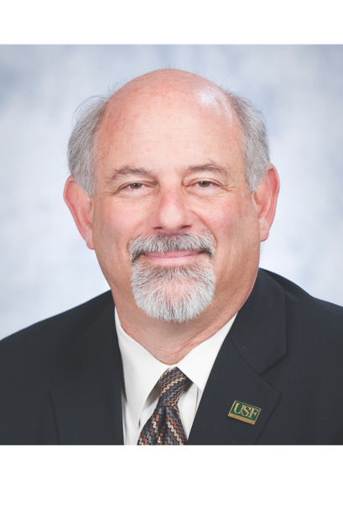

**Dean and Professor of Communication USF College of Arts and Sciences**

Eric Eisenberg, Ph.D., is a nationally recognized scholar in the strategic use of communication to promote positive organizational change. He has published extensively in national and international scholarly journals and is a widely sought-after consultant. In addition, he has previously held faculty appointments at the University of Southern California and Temple University and served as chair of the USF Department of Communication from 1996 to 2006.

Eisenberg was appointed dean of the USF College of Arts and Sciences in March 2010. As interim dean from 2008-2010, he guided the college through a complex process of restructuring that led to the establishment of the School of Humanities, School of Social Sciences, and School of Natural Sciences and Mathematics, as well as steering the efforts to integrate new academic units into the college. He supported the recruitment of outstanding new faculty from the United States and abroad, strengthened the college’s leadership and cultivated a greater sense of scholarly community across the college.

Under his leadership, the College of Arts and Sciences received its largest donation ever from USF Board of Trustee Vice Chair Jordan Zimmerman, who generously donated $10 million to name the Zimmerman School of Advertising and Mass Communications. Eisenberg has played a key role in developing the most unique advertising program in the country, the Zimmerman Advertising Program, which is a joint effort with the Muma College of Business.

## Lt. Gen. Martin R. Steele

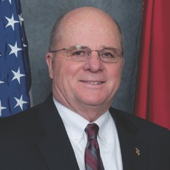

* 1. **Marine Corps (Retired)**

**USF Associate Vice President for Veterans Partnerships USF Executive Director of Military Partnerships**

**USF Co-Chair of the Veterans Reintegration Steering Committee**

Born in Philadelphia, Penn., and raised in Fayetteville, Ark., Lt. Gen.

Martin R. Steele enlisted in the Marine Corps in January 1965. He

rose from private to three-star general, culminating his military career as the deputy chief of staff for plans, policies and operations at Headquarters, U.S. Marine Corps, in Washington, D.C., in August 1999. A decorated combat veteran with more than 34 years of service, he is a recognized expert in the integration of all elements of national power (diplomatic, economic, informational and military) with strategic military war plans and has served as an executive strategic planner/policy director in multiple theaters across Asia. His extraordinary career was chronicled as one of three principles in the award-winning military biography “Boys of ’67” by Charles Jones.

Upon his retirement from active duty in 1999, he served as president & CEO of the Intrepid Sea- Air-Space Museum in New York City. Under his leadership, they adopted the mission statement of “Honor our heroes, educate the public, and inspire our youth about the price of freedom.” This creative branding strategy resonated with all audiences and was the early catalyst for the transformation of the Intrepid from just another New York City destination location to the near icon status it enjoys today among educators, historians, international visitors and military veterans. Shortly after the attacks on Sept. 11, 2001, Steele invited the FBI to use the Intrepid to conduct their investigations. Within 48 hours, Intrepid was once again in service as the temporary headquarters for more than 750 FBI agents.

In 2015, he was appointed to the Congressionally mandated Commission on Care to undertake a comprehensive evaluation and assessment of access of veterans to health care from the Department of Veteran Affairs and strategically examine how best to organize the Veterans Health Administration, locate health care resources, and deliver healthcare to veterans during the next 20 years. The Commission was made up of 15 voting members selected by Congress and the President.

Steele is a graduate of the University of Arkansas where he obtained a B.A. degree in history (’74) and was recognized as a distinguished graduate of the Fulbright College of Arts and Sciences. He is a recipient of the 2013 Arkansas Alumni Award Citation of Distinguished Alumni which recognizes exceptional professional and personal achievement and extraordinary distinction in a chosen field. He also holds three master’s degrees from Central Michigan University, Salve Regina College and the Naval War College.

## Adib Farhadi, Ph.D.

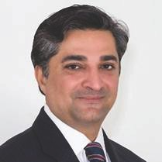

**Coordinator of Executive Education Program Assistant Professor**

**USF College of Arts and Sciences**

Adib Farhadi, Ph.D. is the coordinator of executive education program and assistant professor at the University of South Florida College of Arts and Sciences. He is a recognized global leader in post-conflict stabilization and reconstruction with more than 15 years of experience in project management and professional development.

Farhadi has written, trained and advised a variety of international organizations in areas such as strategic and conflict zone analysis, stabilization and reconstruction efforts, economic analysis and professional development. He has held progressively higher levels of responsibility such as serving as the deputy minister of commerce and industry for the Afghan government, executive director for the Afghanistan National Development Strategy, chief negotiator for WTO accession and senior advisor to New Silk Road Initiative.

Farhadi most recently served as visiting scholar at Johns Hopkins University, School of Advanced International Studies (SAIS) and postdoctoral fellow at University of Canberra, Institute for Governance & Policy Analysis.



# Strategic Communication

& Negotiations

Eric M. Eisenberg, Ph.D. Lt. Gen. Martin Steele (Ret.) Adib Farhadi, Ph.D. *University of South Florida*

Sept. 28-29, 2016

Tampa, FL

## Welcome and introductions



* + - Introduction of instructors and special guests
    - Perspective on communication of SOCOM leadership
    - Why are we here?
      * To build greater awareness and personal capacity for using strategic communication to build stronger relationships and accomplish your objectives
      * To better understand how to apply principles of strategic communication and negotiation to practical challenges that you encounter in your work

2

## Technical brilliance is never enough!

* + - Emotional intelligence and interpersonal skill are the key differentiators for leadership success
    - Strategic communication is invaluable: The ability to not just say whatever is on your mind but rather to make conscious communicative choices based upon your particular goals and a deep understanding of the situation and of your audiences.

3



## Learning objectives



* Better understand your communication style
* Define strategic communication as a unique approach
* Learn how to build successful collaborative relationships
* Understand the differences between cross-cultural international negotiations and traditional negotiations
* Understand the dynamics of international negotiations and conflict resolution, and examine how culture can impact the outcomes
* Learn how to choose and apply negotiating tools

4

## Getting started

At your tables, please introduce yourself and discuss:

* What is the most significant communication challenge you have faced so far in your career?
* What would you **most** like to learn about strategic communication and negotiations in this workshop? How is strategic communication most relevant to success in your role?

5



## Agenda



**Day 1: Strategic Communication**

8:30 - 9:15 Welcome and introductions, getting started

9:15 - 10:00 What is strategic communication?

10:00 - 10:15 Break

10:15 - 12:00 Understanding your communication style

12:00 - 1:00 Lunch

1:00 - 2:30 Collaborating across differences

2:30 - 2:45 Break

2:45 - 4:00 Promoting positive dialogue

4:00 - 4:30 Reflections on days learnings,

preview of Day 2

6

## Agenda

**Day 2: Strategic Negotiations**

8:30 - 9:00 Welcome back, nuggets from yesterday

9:00 - 10:00 The process of strategic negotiations – the

fundamental 10:00 - 10:15 Break

10:15 - 12:00 Cross-Cultural Negotiations – application

12:00 - 1:00 Lunch

1:00 - 2:30 Case Study 1: Engaging with Dept. of State

Case Study 2: Village Stability Operations 2:30 - 2:45 Break

2:45 - 4:00 Cultural Intelligence to address difficult

situations

4:00 - 4:30 Takeaways, principles for practice

7



## What is strategic communication?



* Communication is a learned skill like tennis or scuba
* Communication skill is key to effective leadership, influence and reform
  + More negative things happen due to poor communication than practically anything else in complex social systems (e.g., natural hazards, medical error)
* Systems thinking and conscious communication are the two abilities that separate the good from the great
  + Expressives, automatics, and conscious communicators
  + Not all communication is strategic
* Think of the best communicator you have ever known. What did they do or say that made them so good?

8

## Strategic communication supports organizational interests

* Strategic communication should be help support larger organizational objectives.
* Each individual strategic communications action is connected to relationships and larger organizational objectives.
* Failure to understand the bigger picture can be harmful to an organization.
* Why is strategic communication crucial for SOF?

9

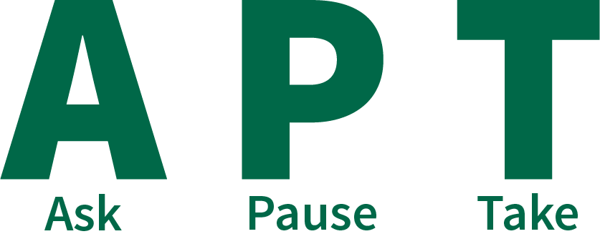

## The APT model of strategic communication



yourself honestly how you are already communicating

and consider your audience and your goals before communicating

steps to solicit honest feedback about how your communication is perceived

10

## Ask yourself

#### A Ask yourself honestly how you are already communicating

* Hold up the mirror
* Maximize self-awareness about how you are typically seen
* Identify patterns in words, gestures, and tone.
* Ask trusted colleagues how they perceive you as a communicator

11



## Pause and consider your audience and your goal



#### P Pause and consider your audience and your goals before communicating

* Who is your primary audience, and what is their world view? How will they take your message?
* Who are other potential audiences you may not intend to reach but who may be exposed to your communication
* Is there a purpose for communicating? If so, what is the purpose?

12

## Take steps to solicit feedback

#### T Take steps to solicit honest feedback about how their communication is perceived

* Observe naturally occurring reactions, responses, feedback
* Solicit honest feedback
* Calibrate the extent to which the feedback is an indication of communication success or failure
* Use feedback to incrementally improve communication, in the moment—real time

13



## Know your audiences



* Who do you need to communicate with to achieve your objective?
* Who influences who?
* What do you want them to do?
* What do they know about your issues?
* Are they interested in your issues?
* What are the best ways to reach them?

14

9/26/16



## Where your strategic communication happens

TOP FORMAL CONTRACT SOCIETY

* + USG Embassies, Agencies, Foreign Ministries

TRUST GAP / CAPACITY GAP

* + District Centers, Foreign Military, Headquarters, Regional Consulates

BOTTOM INFORMAL/STATUS SOCEITY

* + Tribal Elders, Villages, Neighborhoods, Project Managers

15

## Strategic communications – Challenges

* You are dealing with complex issues that your leaders want solved
* You have limited authority, resources and knowledge (at your level) toward addressing these big problems
* Trust-depleted, environments are your domain.
* You are often a “guest in someone else’s headquarters,

agency, functional or geographic domain

* You are face to face with diverse cultures and

disciplines, replete with pre-existing biases toward you, and you toward them

16

8

## Strategic communications – challenges

* Square peg in a round hole – You are caught in the middle of inter-state foreign policy initiatives clashing against intra-state, clan realities
* You must endure an operational tempo that drives you toward reactionary behavior
* Others?

17



## Group Activity: The Physical Metaphor



* Pass things around the room counting the number of times something is dropped.
* What are some parallels between passing objects and passing information, and expectations?
* When have you “dropped the baton” and what could you have done differently?

18

## Key point

* In communication, the only message that matters is the one that is received.

Requires:

* Real time monitoring/feedback
* Respect for message and person
* Considerable practice, does not come naturally to most people
* Refocusing one’s communication goal from message delivery to “evidence” of grasping

19



## Understanding your communication style



* First and most important challenge is to develop a deep appreciation for the uniqueness of your own perceptions, your specific temperament and world view
  + Seeing yourself as others see you is a huge challenge
  + In the U.S., ALL attempts to improve communication among people of different races must begin with helping Caucasians to understand that they have ethnicity
  + The fundamental communication problem is the belief that one’s perceived reality is THE only reality

20

## You must first empty your cup

* A university professor went to visit a famous Zen master. While the master quietly served tea, the professor talked about Zen.
* The master poured the visitor’s cup to the brim, and then kept pouring. The professor watched the overflowing cup until he could no longer restrain himself.
* “It’s overfull! No more will go in!” the professor blurted. “You are like this cup,” the master replied, “How can I show you Zen unless you first empty your cup.”

21



## Ask yourself



* How am I ALREADY communicating?
* Where do I get my data about this?
* How can I get more?

22

## Collaborating across differences

* How observant are you???
* What does this video tell you about the partial nature of perception? About the possibility of collaborating with others?

23



## Collaborating across differences



* Once you understand your own world view, you need to develop a deeper appreciation of others’ perceptions
* Peoples’ communication styles tend to vary across two primary dimensions
  + Extraversion vs. introversion
  + Focus on task vs. focus on people
* Influenced but not determined by culture
* What has been your experience with “type” analysis (DISC, Myers-Briggs, etc.?)

24

Fast Pace, Think Out Loud Action, Big Picture

Task Results Bottom Line

People Process Relationships

|  |  |  |  |
| --- | --- | --- | --- |
| Direct and Decisive (Driver) | | Outgoing and Optimistic (Expressive) | |
| Logical and Precise (Analytical) | | Consistent and Supportive (Amiable) | |
|  | Moderate Pace, Think Internally Planning, Details | |  |

25

## Leadership priorities

Drive Goal orientation

Directness Speed Decisiveness

Creativity Vision/Big picture Possibilities Motivated people Fun/Enthusiasm

Teamwork Collaboration Respect/Tact Quality process Preparation

Accuracy Thoroughness Completion Analysis/Logic Fairness

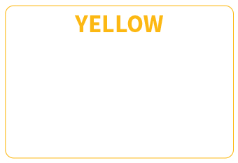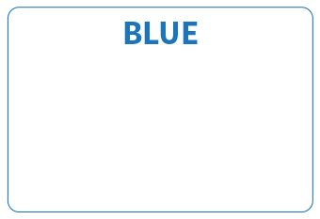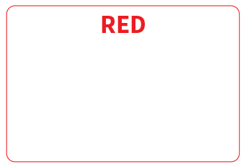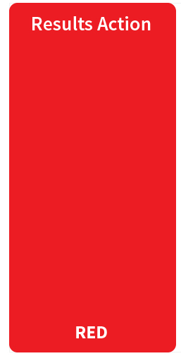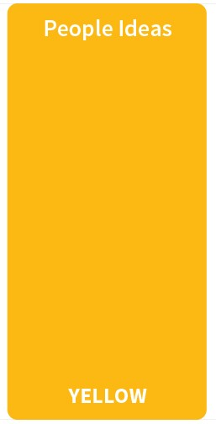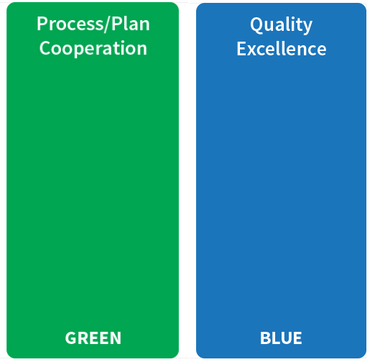

26

## Collaborating across differences

* Strength: Something you do well or easily
* Blind spot: A strength that is overused

*Confidence overused becomes arrogance Decisiveness overused becomes controlling Accommodating overused becomes passive*

* Are you aware of your blind spots? If so, what do you do to about them when relating to others?

27

Fast Pace, Think Out Loud Action, Big Picture



RED

Task Results Bottom Line

BLUE

**Po tential St rengths:** Results focused Direct & Decisive Get things started Take risks Challenge status quo Driven to achieve Confident

**Po tential St rengths:** Quality oriented Detail focused

High standards Well organized Analytical/Logical Diplomatic Fair & Just

**Po tential St rengths:** See the big picture Creative

Motivate & inspire Optimistic & enthusiastic See new possibilities Personable

Persuasive

**Po tential St rengths:**

Easy going

See multiple viewpoints Calming influence Supportive

Good listener Careful and prepared Reliable

YELLOW

People Process Relationships

GREEN



Moderate Pace, Think Internally Planning, Details

28

9/26/16

Fast Pace, Think Out Loud Action, Big Picture

RED

Task Results Bottom Line

BLUE

**Po tential Blindspots:** Over-controlling Domineering Defensive Blunt/insensitive Inflexible

Arrogant

**Po tential Blindspots:**

Over analyze

Lost in detail Unrealistic standards Overly critical Need to be right Aloof

**Po tential Blindspots:** Unrealistic ideas Attention-seeking Lack follow-through Over-expressive Overlook details Easily bored

**Po tential Blindspots:** Too accommodating Overly passive Resist change

Slow to start

Indecisive

Avoid risk & conflict

YELLOW

People Process Relationships

GREEN



Moderate Pace, Think Internally Planning, Details

29

## Understanding your communication style

Summary:

* There is no one right or best style
* Understanding your current style as others see it is a precondition for learning anything new
* If you are unaware of your blind spots, you are the only one!
* Adapt and connect to others’ preferences to the degree that you can
* Avoid the cycle of withdrawal and resentment that accompanies misunderstandings over time

30

15

## Group activity: Cool Bummer

* Objective: Try to get what’s cool for you *and* give what’s cool for the other person

31



## Fostering dialogue: the nuts and bolts



* Dialogue versus discussion
* All of us is smarter than any one of us
  + The blind men and the elephant
  + Bruce comes to class
  + The “three faces of Bill”
* Learning by expanding

32

## Leadership is often about influence, not control

* Flocks and boids
* Neural networks in AI
* The orchestra conductor’s expertise
* Influence versus control

33



## Fostering dialogue as a means of influence



* Use inquiry to continually invite others to share the reasoning for their conclusions
* If you offer a conclusion or belief, add how you came to that conclusion
* You can find common ground only if you back down the ladder of inference from conclusions to experience
* Encourage everyone to speak in terms of their personal experience, and you do it too
* Not “unilateral interventions don’t work” but “in my experience, unilateral interventions have not had the impact that I would have expected.”

34

## Fostering dialogue

Discuss in pairs:

* How can we invite others into dialogue and develop trust, even when we see the world very differently and have different objectives?
  + In your experience, what actions build positive energy and trust?
  + What actions build negative energy and tentativeness?

35



## Fostering dialogue



What are some ways that you have found to promote dialogue?

* Stop talking. Wait. You may be surprised by the good ideas others have if you wait long enough
* Limit psychological and physical noise
* Make your thinking visible
* Suspend judgment. Try to see things from someone else’s perspective.
  + If you are puzzled by another’s position, sincerely ask for their reasoning which will reveal their interests and create the possibility of common ground. If others seem puzzled by you, share your own reasoning. You can’t argue conclusions.

36

## Fostering dialogue

What are some ways that you have found to promote dialogue?

* Ask questions, don’t make pronouncements.
* When things get sticky, go slow. Don’t rush things just to lower the anxiety level, you may miss out on an important lesson.
* Don’t see every talk turn as a chance to either agree or disagree. Use “and” not “but.” Use phrases like:
  + I have a different perspective.
  + I see the situation differently.
  + I have an alternate view.

37



## Fostering dialogue



Or say this…

* *“Here’s what I know about the situation.”*
* *“These are the criteria I used.”*
* *“This is the logic I employed to arrive at this recommendation.”*
* *“Here are some reasons that, for me, make this the best way to go.”*
* *“Let’s look at the data I used to support my decision.”*

38

## Fostering dialogue

And while you’re at it...

* *“I don’t have a complete understanding of the situation.”*
* *“I may have made a bad call here.”*
* *“I can’t answer that question, I just don’t know.”*
* *“I am not an expert in that area.”*
* *“I may not know enough yet to answer.”*

39



## Applications and examples



* What is rapport and why does it matter? In general, how does the quality of relationships shape the communication process?
* How does media choice matter in strategic communication effectiveness?
* How does strategic communication differ in times of crisis?

40

## Self-awareness and vulnerability

* While self-awareness, humility, and vulnerability are the hallmarks of effective, emotionally intelligent communicators, these behaviors must be deployed in the context of unequal power relationships
  + Environmental debates about rising sea levels endangering Bangladesh and the pros and cons of “coming to the table”
  + What are some examples of how good communication practices must be modified to take into account existing power relationships?

41



## Takeaways: Self-awareness and vulnerability



#### Remember:

* The more successful you have been in your career, the *less* motivated you will be to change
* Intelligence, leadership, and communication ability are only weakly correlated
* More about discipline and commitment than insight
* The only message that matters is the one that is received
* The only thing you can control is your own behavior

42

## Takeaways: Self-awareness and vulnerability

#### Remember:

* If you do not know your weaknesses as a communicator, you are the only one
* Understanding your current communication style as others see it is a precondition for learning anything new—you must “empty the cup!”

43



## Agenda



**Day 2: Strategic Negotiations (Adib Farhadi, Ph.D.)**

8:30 - 9:00 Welcome back, nuggets from yesterday

9:00 - 10:00 The process of strategic negotiations – the

fundamental 10:00 - 10:15 Break

10:15 - 12:00 Cross-Cultural Negotiations – application

12:00 - 1:00 Lunch

1:00 - 2:30 Case Study 1: Engaging with Dept. of State

Case Study 2: Village Stability Operations 2:30 - 2:45 Break

2:45 - 4:00 Cultural Intelligence to address difficult

situations

4:00 - 4:30 Takeaways, principles for practice

44

## Group activity: Let’s talk about the elephant in the room

* Share the most recent negotiation you have been involved.

45

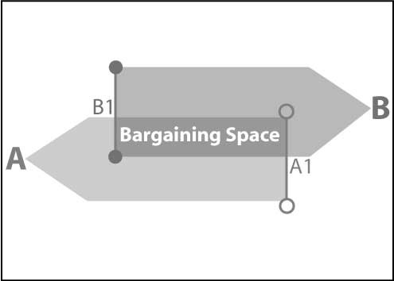

## Strategic negotiations

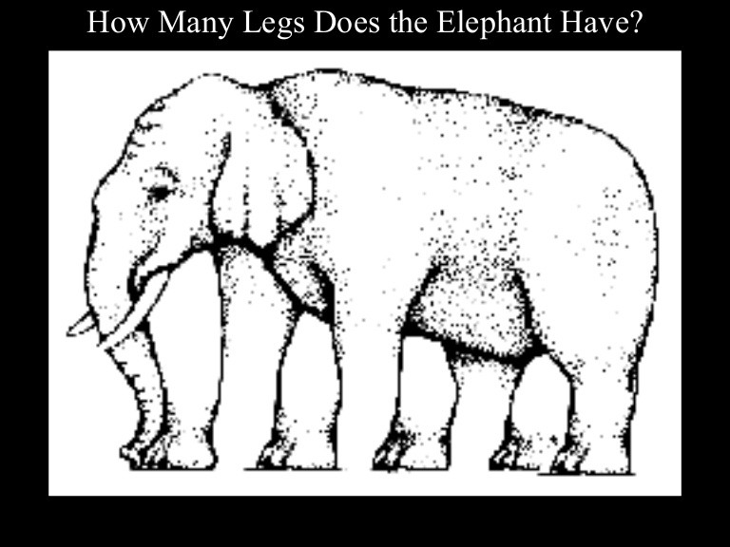

* Building on strategic communication skills to conduct successful negotiations
* Negotiations becomes strategic when factors such as culture, religion, tribalism, building relationships and bargaining are involved
* Strategic negotiation is about influence not control
* Conflicts and instability has increased the need for strategic negotiation resolution

Zone of Possible Agreement (ZOPA)

46

## What is culture and why it matters

“You have to understand the culture you’re getting involved in. We never do a good job of cultural intelligence,…of understanding what makes people tick, what their structure is, where authority

Gen. Anthony Zinni (Ret.)

Former CENTCOM Commander

lies. Cultural bias limits our ability to

understand what is going on around us.”

“System of shared beliefs, values, customs, behaviors, and artifacts that members of a society use to cope with their world and with one another.”

47

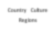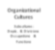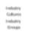

## Culture exists at many levels

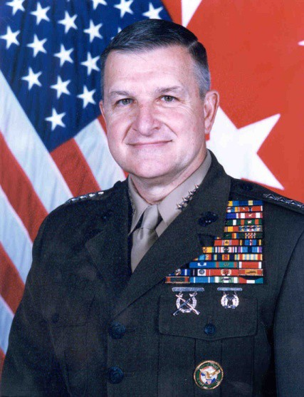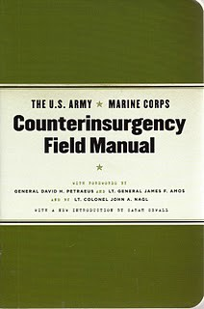

**Country Culture Regions**

**Industry Cultures Industry Groups**

Culture

**Organizational Cultures**

**Subcultures : Depts . & D ivis ions Occupations &**

**Functions**

**Occupational Cultures Occupational Groups**

48

## How do cross-culture negotiation differ from traditional negotiations?

* Misunderstandings occur more often
* We make general categorizations about the other party
* When we feel our values are threathened we get upset
* Understanding characteristics of the issues, parties, negotiating environment and setting
* Challenges of International Negotiations “western negotiations style vs non-Western style” “it’s only business” vs “everything is personal”

49



## Group activity



#### Why are cross-cultural negotiations difficult?

* Please take 5 minutes to identify 5 important challenges to international cross-cultural negotiations

50

## Terms used in negotiation

1. BATNA (best alternative to a negotiated agreement)
2. Power vs. Rights
3. Positions
4. Interests
5. Needs vs. Wants

51



## BATNA



* Best Alternative to Negotiated Agreement (BATNA)
* Result of walking away from negotiation
* Your BATNA tells you when to accept or reject a proposal
  + When a proposal is better than your BATNA – accept
  + When a proposal is worse than your BATNA – reject
* What is your BATNA
  + Your BATNA is bad – softer approach
  + Your BATNA is good – tougher approach

52

## Power vs. rights

* Power is the ability to direct the outcome of negotiations.
* Rights is the entitlement to a negotiating outcome.
* Negotiations can be right-based or power-based

53



## Positions



* A negotiator’s opening offer
* Positional Negotiations
  + Negotiate to win!
  + Short-term or One-time issue
  + Relies on power to force acceptance of a position

54

9/26/16



## Interests

* The unspoken motivation or reason that underlies any given position
* Concern needs, desires, concerns, fears, values, or matters that a party really cares about
* Interest-based negotiations
  + The goal is to “win-win”
  + Solution oriented – problem solvers
  + Relationship are the key
  + Several optimal outcomes – options are not limited

55

## Needs vs. wants

* Needs – those negotiated outcomes that the negotiator must have in order to reach a successful conclusion
* Wants – those negotiated outcomes that a negotiator would like to have

Positions Interests

Needs



56

28

9/26/16



## Group activity

* Please take 5 minutes to give an example of each of negotiating term for your most recent negotiation you have been involved.
* Negotiating terms
  + BATNA
  + Power vs. Rights
  + Positions
  + Interests
  + Needs vs. Wants

57

## Negotiating approaches & outcomes

### Power

I win You lose

I win You win

### Rights Interests

I lose You lose

I lose You win



58

29

9/26/16



## Negotiations across cultures

* Understanding different cultural perspectives
* Guarding against stereotyping and generalizing
* Do not assume that all aspects of the culture are equally significant.
* Utilize strategic communications to build trust and relationships
* Focus on issues, not personalities
* Focus on interests, not positions

59

## “Modern” and “traditional” cultures

**Task-Oriented**

**People-Oriented**

**Results**

**Content**

**Process**

**Context**

**Individual**

**Doing**

**Group Being**

**Present / Past**

**Present / Future**

**Substance**

**Style**

**Short-Term Pre-Ordained**

**Long-Term Informal**

**Linear**

**Free-will Competition**

**Formality**

**Cyclical**

**Cooperation**

60

30



9/26/16

## Cultural values and identity

* Values are often at stake when cross-cultural encounters turn into cross-cultural conflicts
* We are likely to get upset when we feel our values are being challenged or questioned!
* When culture is ignored,

**BEHAVIOR**

**Actions**

**ATTITUDES**

the risk of failed negations and conflict increases.

* Ethnocentrism

**KNOWLEDGE**

**Thoughts/Awarenes s**

**Values,**

**Beliefs,**

**Judgments**

61

## The Iceberg Theory

10%

Visible (above the water)

**Strategic communications is looking below the water line**

90%

Not Visible (below the water)

Norms and Rules Personal Experiences World View & Basic Assumptions

Opinions Viewpoints Attitudes Values Convictions Beliefs

Culture Behaviors Pride Bias Practices

HWiseatvoery(1986)



62

31

## Group activity

* What’s beneath your waterline?

FAMILY STRUCTURE

RACE

ETHNICITY

GE NDE R

VALUE S, NORMS, RULE S

AGE

**CULTURAL IDENTITIES**

TRADITION

GE NDE R

LANGUAGE SOCIAL

IDE NTITY

EDUCATION

RE LIGION BE LIE FS VALUE S

63



## Conflict zone negotiations



* Conflicts and instability have increased the need for conflict resolution
* Counterterrorism, counterinsurgency, asymmetrical, irregular warfare, stability operations and training mission require Alternative Dispute Resolution (ADR) and Peacebuilding negotiations
* The ever increasing role of military (SOF) with people, civil society and international organizations (humanitarian)

64

## Conflict life cycle

65

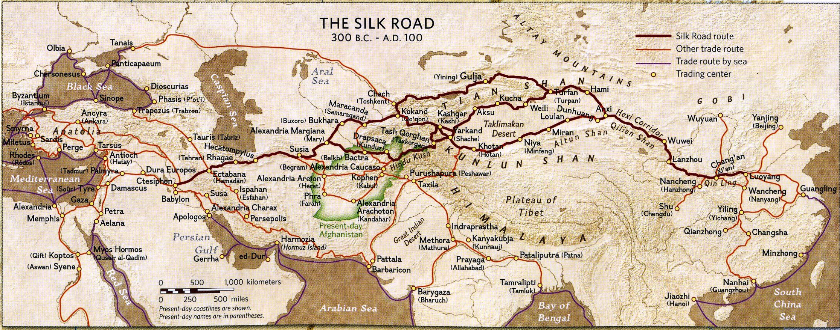

## The Ancient Silk Road - Regional

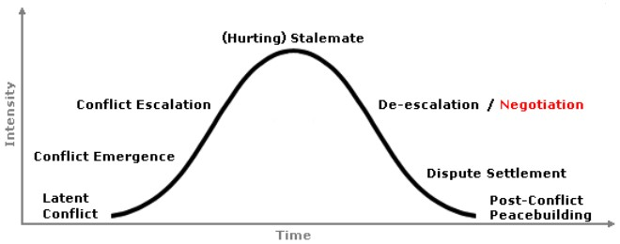

66

## Afghanistan’s cultural makeup - Tribal

67



## Afghanistan’s cultural makeup - Religion

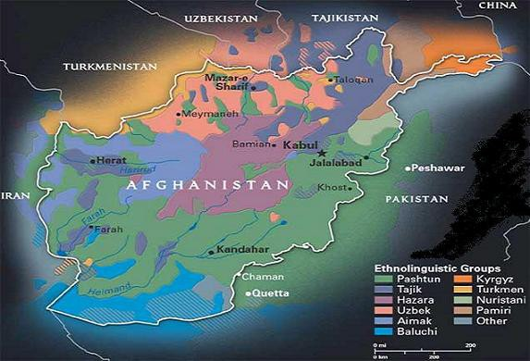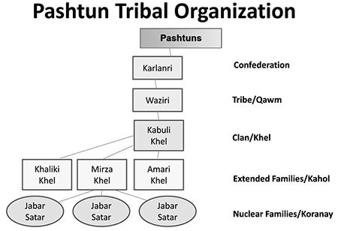

* Islam provides overall social structure; extended family is focal point of social life
* “*When religion is a way of life, it permeates all aspects of everyday social relations, and nothing is separate from it. This is the state of Islam in Afghanistan*.”

**Dr. Thomas Barfield, “*Afghanistan: a Political and Cultural History”***

Statements about culture are never statements about individuals.

68

## Dealing with stereotypes

American Stereotypes of Afghans

* Negative: Always late; slow to decide/act; authoritarian/corrupt; argumentative; overly sensitive; religiously conservative; misogynists
* Positive: Warm and friendly; humble and hospitable; rugged and hardworking

Afghan Stereotypes of American soldiers

* Negative: Direct and informal; impatient; spoiled; wasteful; loud; rude; “loose”
* Positive: Wealthy; generous; hardworking; optimistic; fun- loving

69



## Group activity



* + Please take 5 minutes to agree or disagree with the stereotypes and discuss examples of how stereotyping impairs cross-cultural negotiations.

70

## Case study

### Lieutenant Colonel (Retired) Scott Mann

* + Case Study 1: Engagement with Department of State
  + Case Study 2: Village Stability Operations

71



## Defining cultural intelligence

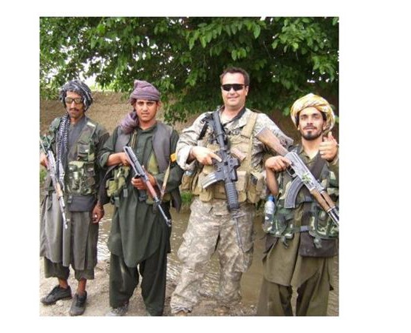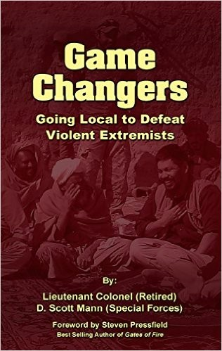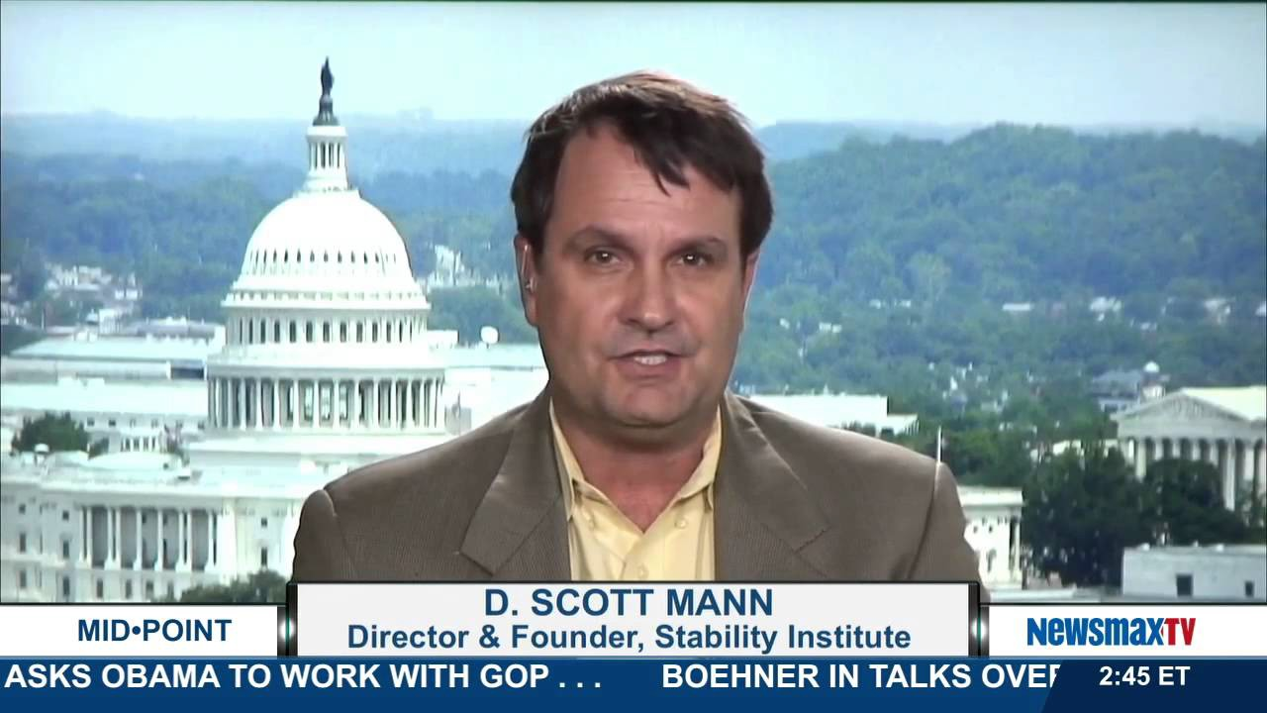

* + “Cultural intelligence can be defined as an analysis of social, political, economic, and other demographic information that provides understanding of a people or nation’s history, institutions, psychology, beliefs (such as religion),

and behaviors.”

*Lieutenant Commander John P. Coles, USN*

* + Cultural Quotient (CQ) is a measure of your ability to work with and adapt to members of other cultures.
    - CQ focuses on problem solving and effective adaptations for various cultural settings.

72

9/26/16

**Afghan Peace Negotiations**

**Iraq, Syria or Afghanistan**

## Cultural intelligence

**Specific Negotiations**

**MICRO**

**(Theater/AO Specific)**

**CQ**

**Situational Awareness**

**The Silk Road Region**

**MACRO**

**(CONUS/Theater Specific)**

**Cultural Training**

**Cultural Education**

**EDUCATION BASE (Humanities that shapes culture)**

Kinetic vs. Non-Kinetic

73

US Army Combined Arms Center



## Cultural intelligence - Afghanistan

* + Culture based upon loyalty to family, clan, tribe, and region before loyalty to nation
  + Honor most important virtue: external public perception of honor - Never criticize in public
  + Hospitality closely linked to honor – refusal is an insult
  + Do not expect immediate answers/decisions - Expect non-committal or vague answers
  + The “Inshallah factor”
  + No concept of personal space; there is no “3 foot personal space”

74

37

## Cultural intelligence - Afghanistan

* + “Losing ” not “Retreating ” is considered a shame; will often retreat in order to avoid shame
  + Don’t engage women socially
  + The “okay” sign of thumbs up is actually a form of a local curse
  + Give a gift in return for one received
  + Conduct negotiations with the senior male
  + *“First meeting, a stranger; second meeting, a brother” – Afghan proverb*

75



## Group activity



* + Based on Afghan cultural intelligence (including the case study information) take 5 minutes to identify 5 cultural “our” and “their” traits that might help or hinder successful negotiations

76

## Understanding high-context and low-context cultures

**Low-Context**

* + - North America and most of

Western Europe

* + - Get down to business first – direct communication
    - Value expertise, performance, logic, facts, and directness
    - Agreement by specific, legalistic contract – contracts are final
    - Negotiations are direct and as efficient as possible
    - Individualistic – “I” and “me”

**High-Context**

* Most of Middle East, Asia,

Africa, and South America

* Establish social trust first – indirect communication
* Value personal relations and goodwill
* Agreement by general trust

– handshake – re-

negotiation

* Negotiations slow and

ritualistic

* Collectivist – “we” and “us”

77



## Negotiating strategies



**High-Context**

* + First take time to build trust and a good relationship
  + Read between the lines – “yes” doesn’t always mean yes and “no” doesn’t always mean “no”
  + Don’t be too direct - Engage in more "small talk"
  + Don't overwhelm them; be less aggressive
  + Soften your words when expressing disagreement – saving face is very important

**Low-Context**

* Use less relationship building time
* No need to read between the lines - “no” means “no” and “yes” means “yes”
* Be “upfront” – communicate directly and clearly
* Be ready to negotiate at the first meeting – not all meetings face to face – phone, internet

78

## Group activity

You have 5 minutes in your table to prioritize a list of 5 key skills that a successful strategic negotiators need.

List your key skills and note the reason why each of your 5 skills is crucial to you as a strategic negotiator.

79



## Things to remember



* + Impossible to cover every aspect of culture
  + Everyone will have different experiences
  + There’s often a disconnect between ideal values or norms and actual practice (especially living at subsistence level)
  + Contradictions and exceptions to every rule and generalization
  + “Only constant is change,…only absolute is complexity”

80

## Review and reflection, key takeaways

* + Take time to understand cultural barriers
  + Several factors influence can influence the process of negotiations, and that the influence of these factors can change over time.
  + The challenge is to understand the simultaneous, multiple influences of several factors on the negotiation process and outcome and to update this understanding regularly as circumstances change.

81



## Application



* + Please take 5 minutes to identify a few key insights you learned and list some concrete actions you intend to take to improve your strategic communication and negotiation skills

82



## Thank You

Strategic Communication

& Negotiations

* Eric M. Eisenberg, Ph.D.
* Lt. Gen. Martin Steele (Ret.)
* Adib Farhadi, Ph.D.
* *University of South Florida*

• Sept. 28-29, 2016

* Tampa, FL

83